Introduction

In the study of osmosis in IGCSE biology, the concept of root osmosis was thoroughly analyzed and a series of experiments were conducted to understand its impact on plant growth. The findings revealed that the water in the soil is a complex mixture of various salts, each having unique effects on the plant growth. This sparked my interest and inspired me to conduct an in-depth investigation on the relationship between salt concentrations and plant growth. Green gram was selected as the test subject for this experiment due to its widespread availability and common usage in gardening. As a result, the data collected from this experiment would provide valuable insights on the impact of different salt concentrations of MgSO₄ on the root and shoot growth of a common plant species, greed gram. Furthermore, my background knowledge in botany, aided by my mother's passion for gardening and my previous experience studying IGCSE biology, enabled me to approach this experiment with a well-informed and systematic approach. The purpose of this experiment was to determine the effect of different salt concentrations on the growth of the root and shoot of the green gram plant. The findings of this study have significant implications for the field of botany and can provide valuable information for future studies on the impact of salt concentrations on plant growth.
Background Information

A salt is an inorganic mineral that dissolves in water. Salts that are abundant in the water found in soil are a mixture of sodium, calcium, potassium, magnesium, chlorides, nitrates, sulfates, bicarbonates and carbonates.As the soil becomes more saline, i.e., an increase of salt concentration in the soil, plants are unable to absorb it from the soil. This is due to the plant roots containing different concentrations of salt ions that help in the natural flow of water from the soil, into the plant roots. The plant root containing a higher concentration of ions allows the water to flow from the area of high-water potential (in the soil) to low-water potential (in the root). This is caused by Osmosis- which is the movement of water molecules from a region of high-water potential to a region of low water potential. When the salinity of the salt in the soil surpasses the salinity of salt in the roots, the water molecules move from the roots to the soil, which eventually causes the plant to dehydrate, causing a decline in yield and in some cases, even the death of the plant. This is due to salt stress, the accumulation of excessive salt contents in the soil which eventually results in the inhibition of crop growth and leads to crop death.

Magnesium is the main element in the chlorophyll molecule in the plant tissue. In the case of magnesium deficiency, the lack of chlorophyll results in poor and stunted plant growth. Magnesium also helps trigger particular enzyme systems. Sulfur is another crucial plant nutrient. It is required for the growth and development of all crops. It helps in formation of chlorophyll, production of protein, synthesis of oils, activation of enzymes and more.

Magnesium sulfate, MgSO₄, is a naturally occurring mineral. Also known as Epsom salt, it helps the seeds germinate, increases chlorophyll production and fend off pests. It acts as a plant fertilizer since it can reverse magnesium deficiency in the soil. MgSO₄ is formed by the reaction of magnesium hydroxide, sulfur dioxide and air. Epsom salt tastes bitter compared to other typical salts. Using salts to influence the growth of plants is a common method. In the case of MgSO₄, it is said to help plants that require high intake of magnesium and sulfate. For example, Pepper plants, tomato plants and roses. Despite the various beneficial effects of MgSO₄, An excess concentration of the salt becomes deleterious to the growth of the plants. The limit till which the benefits of MgSO₄ prevail and the salt begins inhabiting the growth of the plant is explored in this IA.

I chose to work with green gram seeds since it is widely accumulated in my country. Additionally, it germinates faster, making it a suitable choice for experimental purposes as it yields results faster.
The conduction of the experiment goes as allowing the plant to grow for a week in a petri dish with different concentrations of MgSO₄, and then measuring the root and shoot length for each trial. At first, I tried the entire procedure with the concentrations 1, 2, 3, 4, 5 g/100ml. However, the growth was stunted. Which led me to change my concentrations to a lower value so as to record the limit of MgSO₄and after crossing which concentration will MgSO₄ become harmful for the plants, which I was eventually able to deduce. Hence, I chose the concentrations 0.05, 0.1, 0.2, 0.4, 0.6, 0.8 and 1 g/100ml for this experiment. In order to ensure reliable results, I will be conducting ten trials for each concentration.

Hypothesis

Alternate Hypothesis 1 (H₁): Increasing the concentration of MgSO₄ will result in a significant decrease in the root and shoot growth of germinating green gram seeds.
Justification: Because of the low osmotic potential formed surrounding the seed, excessive soil salt slows seed germination and restricts water intake.

Null Hypothesis 1 (h₁): An increase in the concentration of MgSO₄ will not affect the growth of root and shoot of germinating green gram seeds.

Variables

Independent Variable: MgSO₄ ranging between 0.05 - 1% in concentration.
Dependent variable: The root and shoot length of the Vigna Radiata. It is dependent on the MgSO4 concentration. Measuring the root and shoot length will give a reliable perspective on whether or not the plant of the growth has been affected by the salt concentration.

Controlled Variable:
Table 1.1
Variable | Why is it controlled | How is it controlled
Time: | Variation in time for each trial or concentration can lead to an inaccurate assessment, for plants spend equal amounts of time in each concentration of salt so the difference in time will not affect the growth of the plant. | After putting the seeds in the petri dishes with the solution, I waited for 7 days before measuring.
Amount of MgSO4 solution: | In order to get precise results, the amount of the different concentrated solutions should also be equal. More amount of a particular concentration in a petri dish can lead to increased or decreased growth, hampering the results. | All the petri dishes contained 15 ml of the respectively concentrated solution.
Temperature and light: | The temperature must be the same for all petri dishes. A change in temperature can increase or decrease the growth rate, affecting the results by either increasing or inhibiting growth of a few trials. | All petri dishes were kept in the same area, at room temperature, and received equal amounts of sunlight.  However, These two variables cannot be completely controlled, and it fluctuated from 27 to 29 degree celsius.
Amount of green gram seeds: | The amount of seeds must be equal for all concentrations. Less amount of seeds for one concentration will lead to an inaccurate average for that concentration. | Each concentration contained 15 seeds, 5 seeds in each petri dish and 3 petri dishes for each concentration.
Supply of seed: | Buying the same species of the seeds from different suppliers or on different days may result in erroneous results as the seeds would be varied | Buy a lot of seed from the same supplier on the same day to use for the entirety of the experiment
pH of solution | The pH of the solution used must be the same for all the trails. For example, a lower pH for only a few trials will hinder the experiment because the change in growth then can be deduced as either due to the pH of the solution or the concentration of MgSO₄. | Ensure to use distilled water of the same pH for all trails.

Required materials
Table 1.2
Apparatus | Quantity | Least count | Uncertainty | Used for
Graduated Test tubes | 5 | 0.1ml | ±0.05 ml  (parallax error) | To measure the 15 ml of MgSO₄ solution before putting it in the petri dishes.
Beaker (250ml) | 5 | 50ml | ±25 ml  (parallax error) | To store the stock solutions for each concentration- 0.2, 0.4,0.6,0.8,1.
Petri Dishes | 18 | - | - | To put the water and seed in. 3 for each of the 5 concentrations + 3 for control
Spatula | 1 | - | - | To measure the amount of MgSO₄
Scale tile (ruler) | 1 | 0.1cm | ±0.05cm  (parallax error) | To measure the length of the root and shoot of the plant.
Weighing balance | 1 | 0.01g | ±0.005g  (parallax error) | To weigh the MgSO₄ powder in order to make the concentrations.
Thread | 1 | 0.1 cm | ±0.05 ;cm  (parallax error) | To help measure the length of the root shoot growth. Helps with the curved structure of the plant.
Stirrer | 1 | - | - | To help stir the solution after putting MgSO₄ in the water.

Materials
1) 10 g of MgSO₄
2) 600 ml distilled water
3) 100 green gram seeds

Safety, ethical and environmental considerations

Risk assessment: There is no risk in the procedure as such. It is a safe experiment; no harmful chemicals are being used and there is no chance of getting harmed. Glass apparatus was kept far away from edges to prevent tipping over and breaking. No wet hands used near electric sockets.

Ethical consideration: There are no ethical implications associated with this experiment.

Environmental impacts: This experiment has no environmental impact. The salt used is not harmful to the environment but was treated with care and was not spilled. It was disposed of when its use was over into a chemical waste bin.

Procedure
Part 1- preparing the solutions
1. Using a Weighing balance, take out 0.2 grams of MgSO₄.
2. Take beaker 1, label it as 0.2 and pour 100ml of water in it
3. Put the 0.2 grams of MgSO₄ in the ‘0.2’ beaker and mix it with a stirrer.
4. Store it for later.
5. Repeat steps 1 to 4 for 0.4g, 0.6g, 0.8g and 1g.

Part 2- setting up the plants
1. Set out the 18 petri dishes in 6 rows, 3 petri dishes in each row
2. Label the rows and the petri dishes according to the concentrations-

Row 1- control- No MgSO₄ added, only 100ml water.
Row 2-0.05g/100ml
Row 3-0.1g/100ml
Row 4- 0.2 g/100ml
Row 5- 0.4 g/100ml
Row 6- 0.6 g/100ml
Row 7- 0.8 g/100ml
Row 8- 1.0 g/100ml
3. Label all the petri dishes with their respective concentration
4. Using a graduated test tube, pour 15 ml of the concentrations in the respective petri dishes
5. Put 5 green gram seeds in each petri dish, at a distance and avoiding the corners. (in total 15 seeds per concentration)
6. Make sure all the air bubbles in the petri dishes are clear by tapping them on the workstation lightly till all the bubbles are gone.
7. Choose a spot with ample sunlight and space and lay out all the petri dishes for 7 days.

Part 3- measuring and recording the data
1. After 7 days, open the lid of the petri dishes.
2. Take one plant out at a time.
3. Put it against a scale tile, straighten out the root for a valid result and measure the length.
4. Record the data in cm using the ruler on the scale tile.
5. Use a thread and align it with the plant, hold the spot on the thread where the shoot ended and put it against a scale and note down the length.
6. Repeat the same for all the other plants for each concentration and record the data for root and shoot length.

Data
This is the data collected, by following the procedure above:

Root length (cm | uncertainty: 0.05 cm)
Table 1.3- The root length

Trail
Root Length cm$±0.05cm$
conc of MgSO₄ (%) | 1 | 2 | 3 | 4 | 5 | 6 | 7 | 8 | 9 | 10
0 | 6.00 | 4.30 | 3.60 | 1.00 | 7.00 | 5.50 | 8.00 | 13.00 | 10.00 | 9.00
0.05 | 3.00 | 2.50 | 7.50 | 7.50 | 7.50 | 3.50 | 12.00 | 11.00 | 9.50 | 7.00
0.1 | 4.00 | 2.60 | 7.00 | 8.00 | 8.5 | 4.30 | 10.00 | 9.50 | 7.00 | 4.50
0.2 | 3.00 | 2.00 | 3.00 | 2.00 | 2.0 | 6.00 | 4.00 | 5.00 | 4.00 | 3.00
0.4 | 4.00 | 1.50 | 2.00 | 1.50 | 2.00 | 2.00 | 7.00 | 3.00 | 3.00 | 1.00
0.6 | 1.00 | 1.00 | 1.00 | 1.50 | 1.00 | 0.50 | 1.00 | 1.00 | 0.20 | 1.20
0.8 | 0.10 | 0.00 | 0.20 | 0.20 | 0.10 | 0.00 | 0.10 | 0.20 | 0.10 | 0.20
1.0 | 0.00 | 0.10 | 0.00 | 0.00 | 0.00 | 0.00 | 0.10 | 0.00 | 1.00 | 0.00

Shoot length (cm | uncertainty: 0.05 cm)
Table 1.4

Trail
Shoot Length cm $±0.05cm$
conc of MgSO₄ (%) | 1 | 2 | 3 | 4 | 5 | 6 | 7 | 8 | 9 | 10
0 | 11.20 | 10.00 | 7.50 | 8.50 | 13.00 | 11.80 | 12.20 | 10.30 | 9.50 | 12.00
0.05 | 11.50 | 6.00 | 9.00 | 11.50 | 11.00 | 12.00 | 10.50 | 13.00 | 13.50 | 11.20
0.1 | 9.00 | 11.50 | 11.00 | 11.50 | 9.00 | 14.50 | 12.50 | 11.00 | 16.00 | 8.50
0.2 | 5.30 | 6.00 | 7.00 | 8.50 | 8.00 | 10.50 | 10.00 | 12.00 | 11.50 | 13.50
0.4 | 8.50 | 9.50 | 9.00 | 8.50 | 3.00 | 8.00 | 10.50 | 9.00 | 8.00 | 6.00
0.6 | 5.50 | 6.00 | 6.00 | 6.00 | 7.00 | 5.50 | 7.90 | 8.50 | 8.90 | 6.30
0.8 | 2.60 | 3.00 | 3.50 | 2.00 | 2.50 | 3.00 | 2.00 | 2.50 | 3.50 | 2.00
1.0 | 4.00 | 2.00 | 1.00 | 1.00 | 2.00 | 5.00 | 4.00 | 1.00 | 1.00 | 2.50

Data processing

The average growth can be calculated by using the first 10 values of the root and shoot length of each concentration and dividing it by 10.

The average values are:
Table 1.5-
Concentration of MgSO₄ | Average length of root/cm  $±0.05cm$ | STDEV
0 | 6.74 | 2.45
0.05 | 7.1 | 2.27
0.1 | 6.54 | 1.54
0.2 | 3.45 | 1.80
0.4 | 2.7 | 0.75
0.6 | 0.94 | 0.36
0.8 | 0.12 | 0.08
1 | 0.12 | 0.03

Graph 1.1
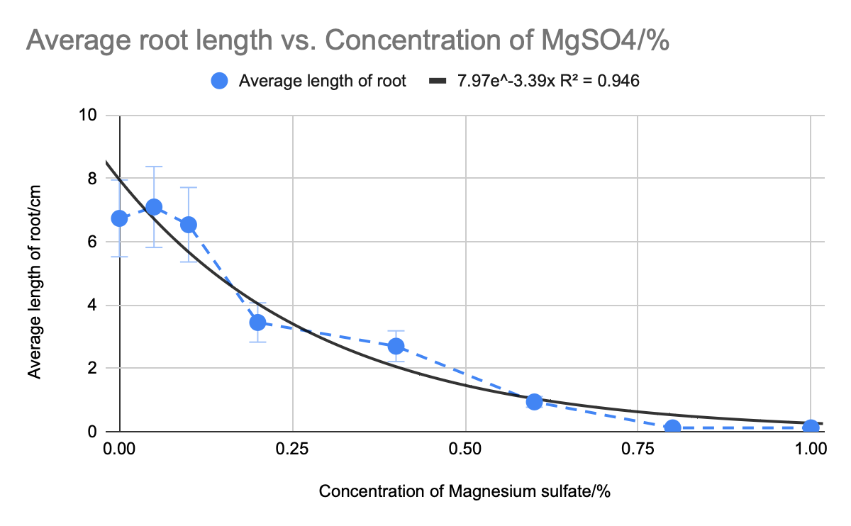

Table 1.6

Concentration of MgSO₄ | Average length of shoot/cm  $±0.05cm$ | STDEV
0 | 10.6 | 1.75625865
0.05 | 10.92 | 2.133749959
0.1 | 11.45 | 2.408895551
0.2 | 9.23 | 2.711313745
0.4 | 8 | 2.108185107
0.6 | 6.76 | 1.250955191
0.8 | 2.66 | 0.5777350412
1 | 2.35 | 0.491643389

Graph 1.2
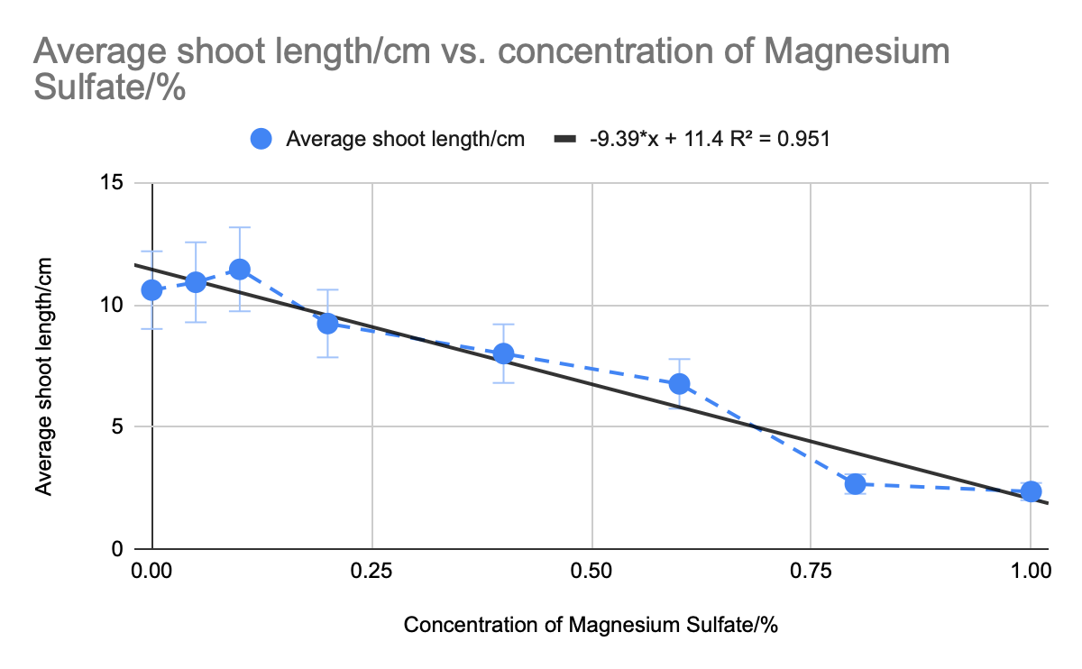
Graphical Analysis
The root and shoot growth of the plant were analyzed with respect to varying concentrations of MgSO₄ in two different graphs. Both graphs illustrate a preliminary upward trend in root/shoot growth, followed by a pronounced downward trend as the MgSO₄ concentrations increased.The initial upward rise, however, is not deemed statistically significant. In contrast, the downward linear relationship between the MgSO₄ concentrations and plant growth is statistically significant. The negative relationship between the two variables is highlighted by the strong R2 values of both graphs, indicating a strong goodness of fit.
In Graph 1.1, the relationship between the root growth and MgSO₄ concentrations is exponential, with an R2 value of 0.946, indicating a robust association. Graph 1.2 displays a linear relationship between the shoot growth and MgSO₄ concentrations, with an R2 value of 0.951, which signifies a strong fit of the line of best fit.The root growth of the plant shows a pronounced exponential decrease in response to increasing concentrations of MgSO₄. The shoot growth, on the other hand, exhibits an initial increase, followed by a downward trend after the MgSO₄ concentration reaches 0.1 g/100 ml. This inverse relationship between the MgSO₄ concentrations and plant growth is further accentuated by the negative gradient values of both graphs.The decrease in root and shoot growth is attributed to the imbalanced soil salinity caused by the elevated MgSO₄ concentrations, which impedes the plant's water uptake. As the MgSO₄ concentrations increase, the root and shoot growth of the plant decrease, revealing a clear inverse relationship between these two variables.
The graph 1.1 above is a polynomial trend line, for it is the best fit for the average root growth per concentration. In graph 1.2 I have made use of a linear trend line to showcase the downward trend in the shoot growth. The differing trendlines for the data is the best fit for it and curates a more accurate $R^{2 }$value and equation. However, An outlier is observed in both graphs at the 0.75 MgSO₄ % concentration. This will further be explored in my analysis.
Data Analysis
T- Test on the root growth:
Table 1.7
intervals | T-value | Difference | Hypothesis
Control- 0.05 | 0.2392 | not statistically significant | Null
Control- 0.1 | 0.1474 | not statistically significant | Null
Control-0.2 | 2.8183 | statistically significant | Alternate
Control-0.4 | 3.2984 | very statistically significant. | Alternate
Control-0.6 | 5.2808 | extremely statistically significant. | Alternate
Control-0.8 | 6.0666 | extremely statistically significant. | Alternate
Control-1.0 | 6.0083 | extremely statistically significant. | Alternate

T-Test on the shoot growth:
Table 1.8
intervals | T-value | Difference | Hypothesis
Control-0.05 | 0.3662 | Not statistically significant | Null
Control-0.1 | 0.9016 | Not statistically significant | Null
Control-0.2 | 1.3411 | Not statistically significant | Null
Control-0.4 | 0.9774 | Not statistically significant | Null
Control-0.6 | 5.6317 | extremely statistically significant. | Alternate
Control-0.8 | 13.2713 | extremely statistically significant. | Alternate
Control-1.0 | 11.3222 | extremely statistically significant. | Alternate

Analysis:

The T-test was carried out using ‘graph pad software.’ This test is conducted to determine the statistical significance of the data- whether there is a significant difference between the independent and dependent variable. I have also made use of the T test to determine which hypothesis (alternate or null) is proven correct.
$d(f)=n_{1}+n_{2}-2=10+10-2=18$
The degree of freedom (df) refers to the maximum number of logically independent values. The degree of freedom (df) for each of the trails was 18. A positive whole number as a degree of freedom value showcases the strong statistical values at hand. By using this knowledge, the tabulated t value was found to be 2.101 using the tabulated t value table. This implies that the alternate hypothesis will be accepted if the estimated t value is larger than 2.101. From table 1.7, it is clear that in the case of root growth, the alternate hypothesis is accepted - which states that increasing the concentration of MgSO₄ will result in a significant decrease in the root and shoot growth of germinating green gram seeds. We can therefore conclude that the null hypothesis is rejected in the case of root growth. In the case of shoot growth, there is not much difference at first, which is why the data is ‘not statistically significant’. However, at and after 0.6% MgSO₄ solution, the t-value increases drastically. This shows that the decrease in shoot length is seen after 0.6%. This also proves the null hypothesis wrong, and the alternate right.
The outlier of 0.75% of MgSO₄ in both the average root and shoot length graph is a result of a random error in the formation of the concentration. Due to human error, the addition of MgSO₄ is more than 0.75 grams, hence the point on the graph is lower than the trendline in both the root and shoot length data.
To conclude, it is evident that the increase of MgSO₄ concentration decreases the growth of the plants.

Conclusion
This experiment aimed to investigate the following research question: Does different concentrations of MgSO₄ (0.2, 0.4, 0.6, 0.8 and 1 g for 100 ml of water) affect the growth of root and shoot of green gram (Vigna radiata) plants, as compared to the control plant growth measured in cm.

The result of the experiment concludes that the alternate hypothesis is proven correct. The alternate hypothesis states that, the change in concentrations of MgSO₄ will have a significant change on the root and shoot growth. The graph makes it clear that the increase in the concentrations lead to a decrease in the root and shoot growth of the plant. Although there was an initial growth in the shoot and root, it was statistically proven to be not statistically significant. It can also be observed from the graph that the line of best fit is a downward sloping line. The trial with 1.0, the highest concentration of MgSO₄, had the lowest growth of root and shoot, which further proves the hypothesis correct.
If higher concentrations on MgSO₄ were used, the root and shoot will not grow at all. This is because there will be a high imbalance of ions in the soil which would stop the water uptake of the plant, resulting in the hampering of the growth. However, A very low concentration of MgSO₄ (0.05 g/100ml) would increase the root and shoot length. This is because of the magnesium ions present in the compound and its benefit to the growth of the plant. It helps in the formation of chlorophyll, production of proteins and many more functions required for plant growth.

Evaluation
Strengths:
- 10 trials were conducted for each concentration of MgSO₄. This ensures that random uncertainties do not affect the overall result of the experiment when the mean is calculated, increasing the accuracy of the result.
- The independent variable was rather easy to manipulate and work with, ensuring no random error in the procedure.
- The statistical test conducted (T-test) further highlights the importance of the data which indicates that the data is precise and shows statistical significance.
- The procedure was safely conducted without any harm to the surroundings.
- The procedure did not require consistent care and attention, which made it very time efficient.
- The external variables that would otherwise affect the enzymatic reaction were identified and controlled to the best of ability.

Weakness and Improvements:
The experimental design used in this experiment was suitable. It resulted in reliable results, however there were several weaknesses that were present in the experiment, which reduced the accuracy and precision of the data.

Errors that affected the accuracy:
Weakness | Significance and impact on environment | Possible improvements
The volume of the MgSO₄ was measured using a measuring cylinder and weighing scale. | Moderately significant. The measuring cylinders have an uncertainty level of ±0.05 ml, which would impact the precision of the value obtained. The weighing scale also has an uncertainty level of 0.01g which could impact the MgSO₄ solutions. | A more efficient way of measuring the volume could be used, for example, a pipette for the solution.
Temperature fluctuations | Moderately significant. Although it is considered, During the night, the temperature will be affected and will drop down to a level perhaps not considered in the experiment. | Use a greenroom with maintained and constant temperature.
Difference in composition of seeds. | Significant. Although bought from the same owner, the composition of the seeds like its pH level might differ. | Check the quality of all the seeds used in the experiment.
MgSO₄ solution | As mentioned in my analysis, a particular concentration of MgSO₄ solution was hampered due to an experimental error by putting more of the compound in the solution. | This can be avoided by a more thorough procedure, making multiple batches of the solution for a value closer to the average trend line.
The ruler used was not completely accurate | Moderately significant. The scale tile has an uncertainty level of 0.05 cm. This could result in the wrong data being recorded. The thread did decrease the error chance but it is there nonetheless. | A more efficient way of measuring would be to use a scale with more precise markings.

Bibliography
“Growth Performance and Root Transcriptome Remodeling of Arabidopsis in Response to Mars-Like Levels of Magnesium Sulfate.” PLOS, 23 August 2010, https://journals.plos.org/plosone/article?id=10.1371/journal.pone.0012348. Accessed 10 February 2023.
“Impacts of salinity | Environment, land and water.” Queensland Government, 1 October 2013, https://www.qld.gov.au/environment/land/management/soil/salinity/impacts. Accessed 10 February 2023.
“Magnesium basics - PMC.” NCBI, https://www.ncbi.nlm.nih.gov/pmc/articles/PMC4455825/. Accessed 10 February 2023.
Malik, Kausar. “Advances in Rice Research for Abiotic Stress Tolerance.” Science Direct, Science Direct, 2019, https://www.sciencedirect.com/book/9780128143322/advances-in-rice-research-for-abiotic-stress-tolerance.
“Root development under control of magnesium availability.” NCBI, https://www.ncbi.nlm.nih.gov/pmc/articles/PMC4205136/. Accessed 10 February 2023.
“[Solved] Which one of the following elements is essential for the for.” Testbook.com, https://testbook.com/question-answer/which-one-of-the-following-elements-is-essential-f--5b978b1cb7cc7b0c47d779ad. Accessed 10 February 2023.

“Saline Soil.” Saline Soil - an Overview | ScienceDirect Topics, https://www.sciencedirect.com/topics/earth-and-planetary-sciences/saline-soil.
https://www.qld.gov.au/environment/land/management/soil/salinity/impacts (“Impacts of salinity | Environment, land and water”)
“[Solved] Which one of the following elements is essential for the for.” Testbook.com, https://testbook.com/question-answer/which-one-of-the-following-elements-is-essential-f--5b978b1cb7cc7b0c47d779ad. Accessed 10 February 2023.
https://www.ncbi.nlm.nih.gov/pmc/articles/PMC4455825/ (“Magnesium basics - PMC”)
Guo, Jianrong, et al. “Exposure to High Salinity During Seed Development Markedly Enhances Seedling Emergence and Fitness of the Progeny of the Extreme Halophyte Suaeda Salsa.” Frontiers in Plant Science, Frontiers Media SA, Aug. 2020. Crossref, doi:10.3389/fpls.2020.01291.
“Root development under control of magnesium availability.” NCBI, https://www.ncbi.nlm.nih.gov/pmc/articles/PMC4205136/. Accessed 10 February 2023.
(“Growth Performance and Root Transcriptome Remodeling of Arabidopsis in Response to Mars-Like Levels of Magnesium Sulfate”)
Malik, Kausar. “Advances in Rice Research for Abiotic Stress Tolerance.” Science Direct, Science Direct, 2019, https://www.sciencedirect.com/book/9780128143322/advances-in-rice-research-for-abiotic-stress-tolerance.

